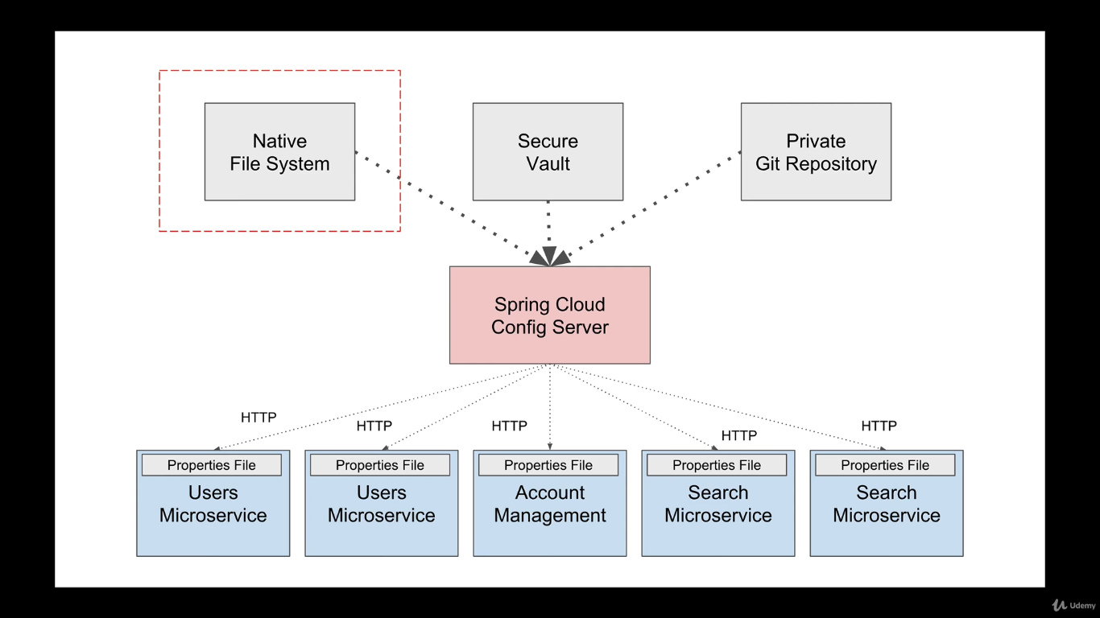

Instead of using Git Repository we will use “Native File System” to store configuration.

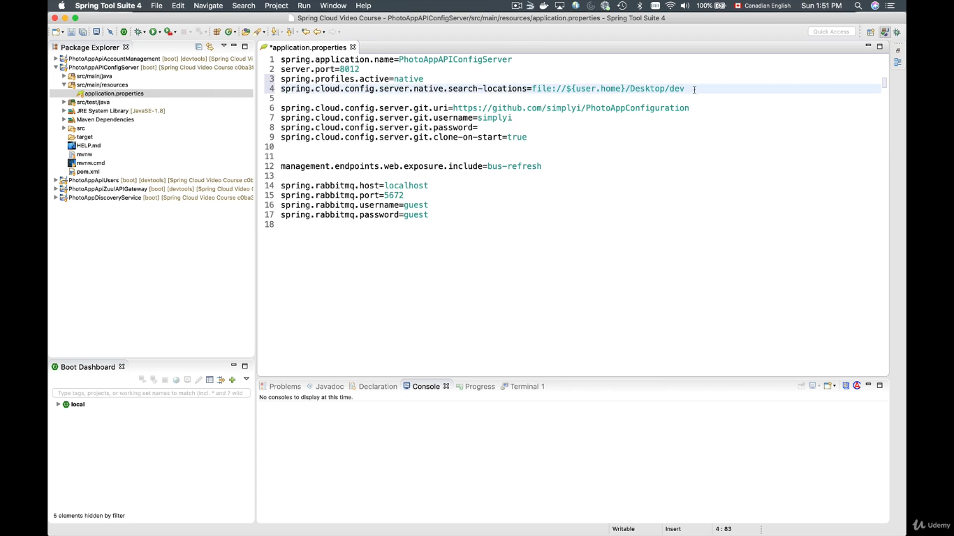

Add these two properties in you config server properties file.

1. Spring.profiles.active = native
2. Spring.cloud.config.server.native.search-location=file://${user.home}/Desktop/dev

The local properties file name should be same as the application name mentioned in “spring.application.name= “xxxx”

Values need to be pasted in native properties file.

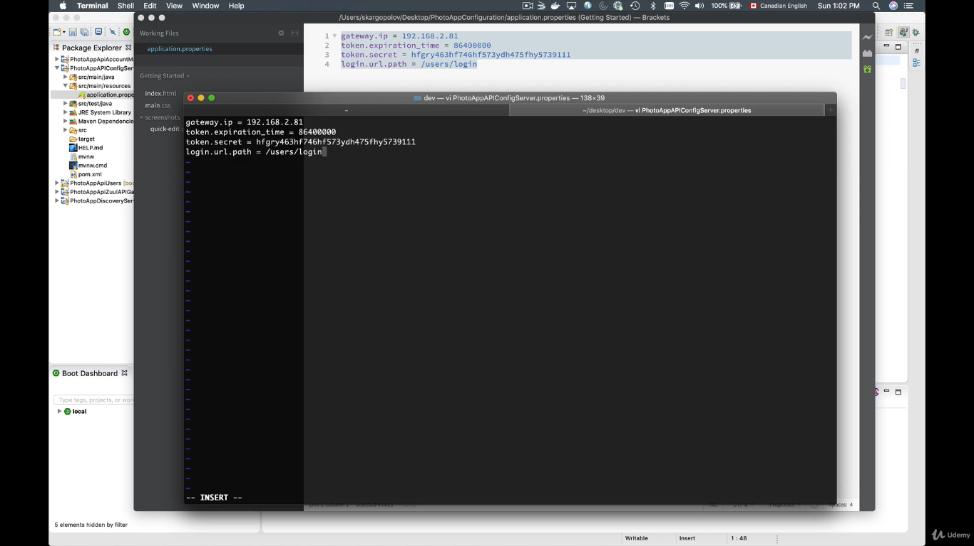

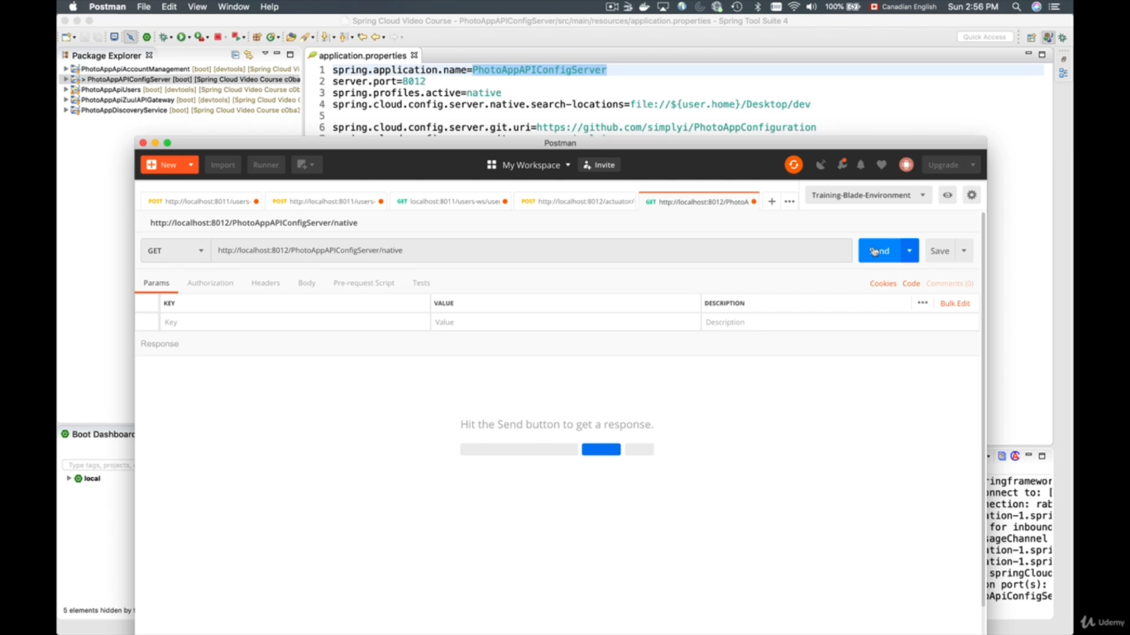

Test the microservice.